AMERICAN INTERNATIONAL UNIVERSITY – BANGLADESH (AIUB)

Department of Computer Science

Faculty of Science and Technology

CSC2210: Object Oriented Programming 2

Spring 2025-2026

Project Report On

InstaAutomate Dashboard

Instagram Automation Management System

Supervised By
[DR. MD IFTEKHARUL MOBIN] Faculty of Computer Science
American International University-Bangladesh (AIUB)

Submitted By
Name | ID
Ashfaq Khandaker | [24-58723-2]
Apon Saha | [24-58041-2]
Ayan Biswas | [24-58036-2]
Fatima Tuj zahara Roja | [23-52689-2]

CO2
Display and verify the implementation of a real-life desktop-based project using the concepts of C# Graphical User Interface with database integration.

Assessment Criteria
Evaluation Criteria | Description
Requirement Fulfillment | Demonstrating a real-life scenario-based desktop application using object-oriented programming concepts
Validation | Validating user inputs and ensuring proper data handling
Verification | Verifying data flow and database functionality

Table of Contents
- Introduction
- Project Objectives
- Problem Statement
- System Overview
- User Stories
- Functional Requirements
- Non-Functional Requirements
- System Architecture
- Database Design
- ER Diagram
- Database Tables
- SQL Queries and Functionalities
- System Modules
- User Interface Description
- Screenshots of Forms
- Technologies Used
- Challenges Faced
- Future Improvements
- Conclusion
- References

Chapter 1: Introduction
InstaAutomate Dashboard is a Windows Forms-based Instagram Automation Management System developed using C#, SQL Server, and ADO.NET. The purpose of the project is to simulate Instagram automation workflows in a desktop-based environment.
The system allows administrators and users to manage automation flows, monitor activity logs, manage Instagram accounts, and simulate Instagram comment-to-message workflows through a professional dashboard interface.
The application also includes authentication systems, role-based access control, dashboard analytics, activity tracking, and CSV export functionalities.
This project demonstrates real-world desktop application development concepts using object-oriented programming principles and database integration.

Chapter 2: Project Objectives
The primary objectives of this project are:
- To develop a desktop-based automation management system.
- To implement CRUD operations using C# Windows Forms.
- To integrate SQL Server database connectivity.
- To implement authentication and role-based authorization.
- To create a dashboard system with analytics and activity logs.
- To simulate Instagram automation workflows.
- To demonstrate software engineering and database management concepts.

Chapter 3: Problem Statement
Modern businesses, influencers, and content creators require automation systems to manage repetitive social media engagement activities efficiently. Manually replying to comments, checking whether users followed a profile, sending direct messages, and distributing promotional links consume significant time and reduce scalability.
The current version of InstaAutomate Dashboard simulates Instagram automation workflows using a desktop-based architecture. However, the long-term vision of the project is to transform the system into a real-time Instagram automation platform powered by Instagram Graph API integration.
The future implementation plan includes:
- Real Instagram account authentication using Meta Developer APIs.
- Real-time follower verification.
- Automated follow-check system before sending promotional links.
- Real Instagram post fetching from connected accounts.
- Post selection dashboard for automation campaigns.
- Real-time comment monitoring.
- Automatic direct message distribution.
- Business-oriented campaign management system.
- Multi-user SaaS-style architecture.
- Advanced analytics and engagement tracking.
The target workflow of the final system will operate as follows:
User comments on a selected Instagram post → System checks whether the user follows the business account → If not followed, the system replies asking the user to follow first → After follow verification, the system automatically sends a special promotional link through direct message → Activity is stored inside dashboard logs and analytics
This architecture aims to transform the project from a simulation-based academic desktop application into a real-world social media business automation platform.

Planned Real-Time Automation Workflow

Step 1: Instagram Account Connection
Business owners will connect their Instagram Business Account using Meta Graph API authentication.

Step 2: Post Synchronization
The system will fetch all Instagram posts from the connected account.

Step 3: Post Selection
Users will select which Instagram post should run the automation campaign.

Step 4: Comment Monitoring
The system will monitor new comments on the selected post.

Step 5: Keyword Detection
The automation engine will detect predefined keywords such as:
- link
- price
- info
- interested
- dm

Step 6: Follow Verification
The system will verify whether the commenter follows the business profile.

If User Does Not Follow
The system will:
- reply asking the user to follow the page first
- wait for follow confirmation
- re-check follow status

If User Follows
The system will:
- send the special promotional link automatically
- store the action inside activity logs
- update dashboard analytics

Step 7: Activity Analytics
The dashboard will display:
- total comments processed
- successful DMs
- follow conversion rate
- campaign engagement analytics

Chapter 3: Problem Statement
Modern businesses and content creators often need tools to manage repetitive social media engagement tasks. Manually replying to comments, sending direct messages, and tracking interactions can be time-consuming.
This project addresses this issue by providing a centralized dashboard system capable of simulating automation workflows and managing Instagram-related activities efficiently.
The project also demonstrates how desktop applications can be integrated with databases to create scalable management systems.

Chapter 4: System Overview
The system contains the following major modules:
- Login and Authentication Module
- Dashboard Analytics Module
- Instagram Account Management Module
- Automation Flow Management Module
- Activity Logging Module
- Role-Based Access Control Module
- CSV Export Module
- Simulation Engine Module
The application follows a layered architecture where:
- Windows Forms handles the user interface.
- Business logic processes automation workflows.
- SQL Server stores all persistent data.
- ADO.NET manages database communication.

Chapter 5: User Stories

Admin

I. Login
Admins can log into the system using valid credentials. After successful authentication, the admin dashboard is displayed.

II. Manage Automation Flows
Admins can add, update, delete, and search automation flows.

III. Manage Instagram Accounts
Admins can connect and manage Instagram accounts.

IV. View Dashboard Analytics
Admins can monitor total accounts, flows, and activity logs.

V. Export Activity Logs
Admins can export activity logs into CSV format.

VI. View System Logs
Admins can monitor all automation activities and simulation events.

User

I. Login
Users can log into the system using their credentials.

II. Run Simulation
Users can test automation workflows using the simulation panel.

III. View Dashboard
Users can monitor automation logs and existing flows.

IV. Limited Access
Users cannot delete flows or manage system-level functionalities.

Chapter 6: Functional Requirements

Authentication Functionalities
- User Registration
- User Login
- Role-Based Authentication
- Session Management

Dashboard Functionalities
- Dashboard Statistics
- Real-Time Log Refresh
- Auto-Updating Counters

Automation Flow Functionalities
- Add Flow
- Edit Flow
- Delete Flow
- Search Flow
- Keyword-Based Trigger System

Instagram Account Functionalities
- Add Instagram Account
- Store Access Tokens
- Display Account Information

Activity Logging Functionalities
- Store Automation Logs
- Track Timestamps
- Export CSV Reports

Simulation Functionalities
- Comment Detection
- Auto Reply Simulation
- DM Simulation
- Follow Verification Simulation
- Link Distribution Simulation

Chapter 7: Non-Functional Requirements
- The system should provide a user-friendly graphical interface.
- The application should support role-based access control.
- The database connection should remain secure and stable.
- The application should prevent crashes using exception handling.
- The system should provide responsive dashboard updates.
- The application should support future scalability.

Chapter 8: System Architecture
The system follows a three-layer architecture:

1. Presentation Layer
Implemented using C# Windows Forms. Handles:
- UI components
- Forms
- User interaction
- Dashboard visualization

2. Business Logic Layer
Processes:
- Automation workflows
- Role validation
- Simulation engine
- Dashboard calculations

3. Database Layer
Implemented using:
- SQL Server
- ADO.NET
- Microsoft.Data.SqlClient
Responsible for:
- CRUD operations
- Query execution
- Data storage

Chapter 9: Database Design
The database used in this project is:

InstaAutomateDB
The database stores:
- user information
- automation flows
- Instagram accounts
- activity logs

Chapter 10: ER Diagram
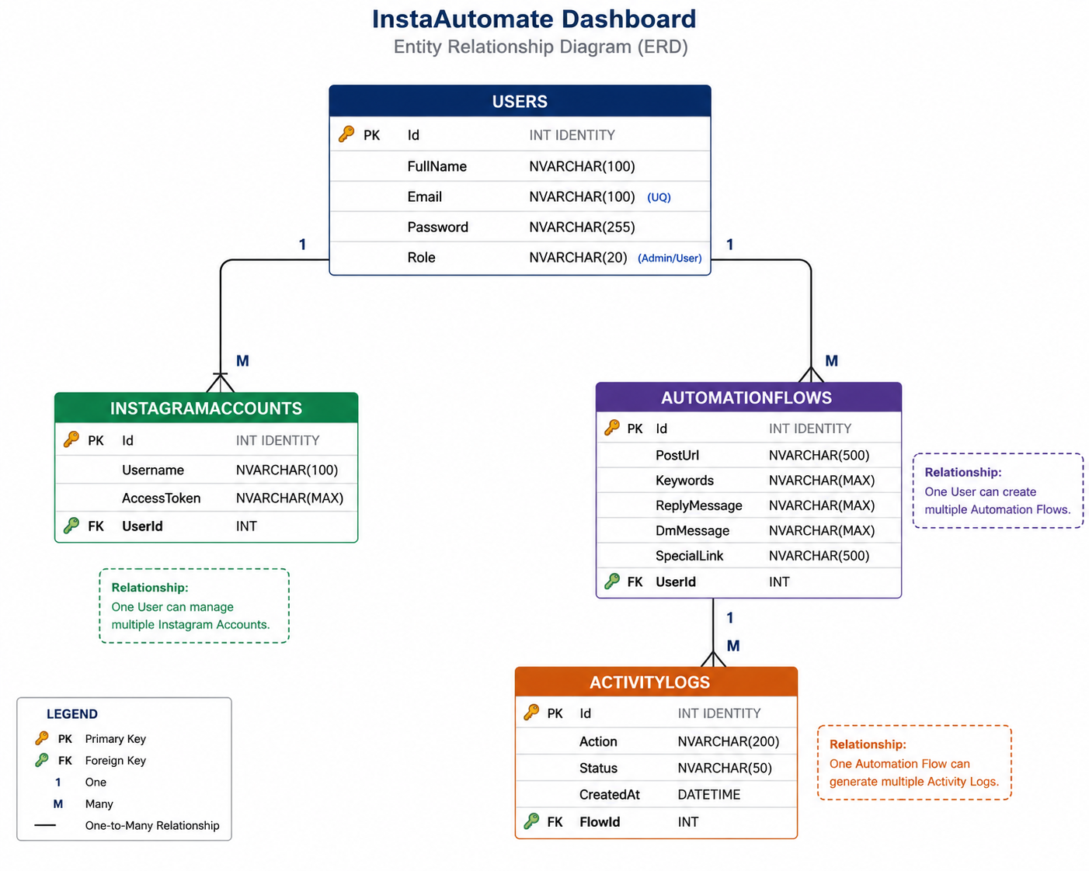

Chapter 11: Database Tables

1. Users Table
Column | Data Type | Constraint
Id | INT | Primary Key, Identity
FullName | NVARCHAR(100) | NOT NULL
Email | NVARCHAR(100) | UNIQUE
Password | NVARCHAR(100) | NOT NULL
Role | NVARCHAR(50) | NOT NULL

2. InstagramAccounts Table
Column | Data Type | Constraint
Id | INT | Primary Key
Username | NVARCHAR(100) | NOT NULL
AccessToken | NVARCHAR(MAX) | NULL

3. AutomationFlows Table
Column | Data Type | Constraint
Id | INT | Primary Key
PostUrl | NVARCHAR(MAX) | NOT NULL
Keywords | NVARCHAR(MAX) | NOT NULL
ReplyMessage | NVARCHAR(MAX) | NULL
DmMessage | NVARCHAR(MAX) | NULL
SpecialLink | NVARCHAR(MAX) | NULL

4. ActivityLogs Table
Column | Data Type | Constraint
Id | INT | Primary Key
Action | NVARCHAR(200) | NOT NULL
Status | NVARCHAR(100) | NOT NULL
TimeStamp | DATETIME | DEFAULT GETDATE()

Chapter 12: SQL Queries and Functionalities

User Registration
INSERT INTO Users (FullName, Email, Password, Role)
VALUES ('Ashfaq', 'ashfaq@gmail.com', '123456', 'User');

User Login
SELECT * FROM Users
WHERE Email='ashfaq@gmail.com'
AND Password='123456';

Add Automation Flow
INSERT INTO AutomationFlows
(PostUrl, Keywords, ReplyMessage, DmMessage, SpecialLink)
VALUES
('post1', 'hello,hi', 'Thanks!', 'Check DM', 'https://google.com');

Update Automation Flow
UPDATE AutomationFlows
SET ReplyMessage='Updated Reply'
WHERE Id=1;

Delete Automation Flow
DELETE FROM AutomationFlows
WHERE Id=1;

Add Activity Log
INSERT INTO ActivityLogs (Action, Status)
VALUES ('DM Sent', 'Success');

Dashboard Statistics
SELECT COUNT(*) FROM Users;
SELECT COUNT(*) FROM AutomationFlows;
SELECT COUNT(*) FROM ActivityLogs;

Chapter 13: System Modules

1. Authentication Module
Responsible for:
- login
- signup
- session handling
- role verification

2. Dashboard Module
Responsible for:
- statistics display
- account listing
- flow listing
- log monitoring

3. Automation Engine Module
Responsible for:
- comment processing
- keyword matching
- DM simulation
- link distribution

4. Database Module
Responsible for:
- SQL connectivity
- CRUD operations
- query execution

5. Export Module
Responsible for:
- CSV export
- log report generation

Chapter 14: User Interface Description

Login Screen
Allows users to securely access the system.

Signup Screen
Allows new users to register.

Dashboard
Displays all system statistics and controls.

Automation Flow Panel
Allows admins to manage automation flows.

Simulation Panel
Used to test automation workflows.

Activity Logs Panel
Displays all automation activities.

Chapter 15: Screenshots of Forms

Login Form
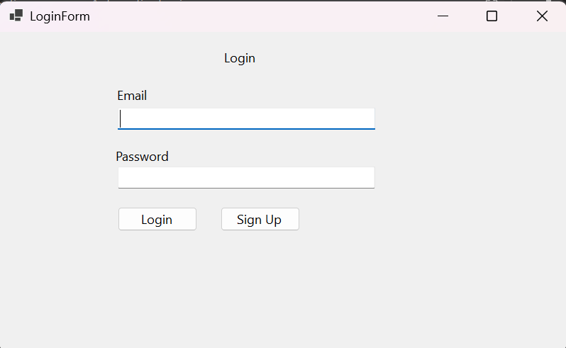

Signup Form
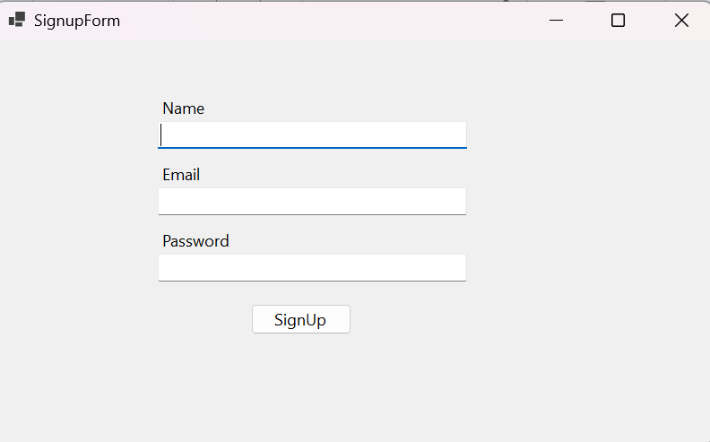

Dashboard Form
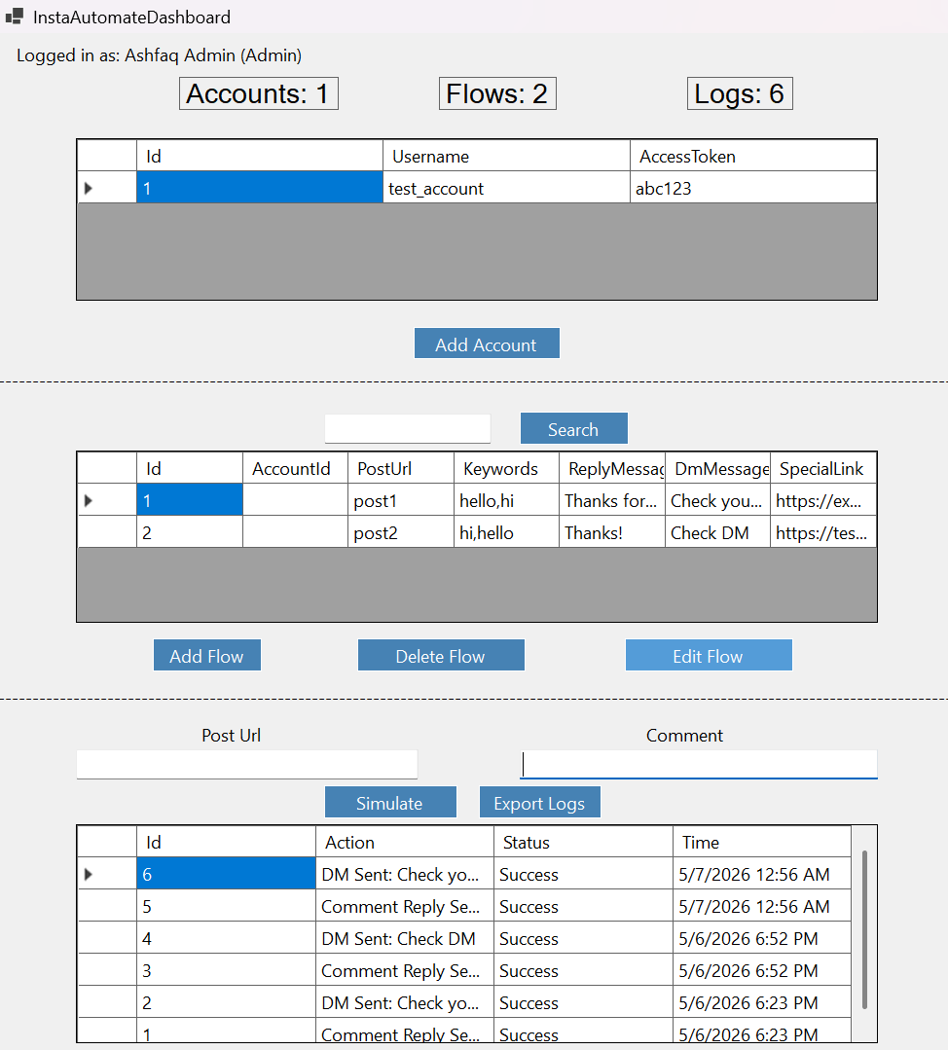

Add Account Form
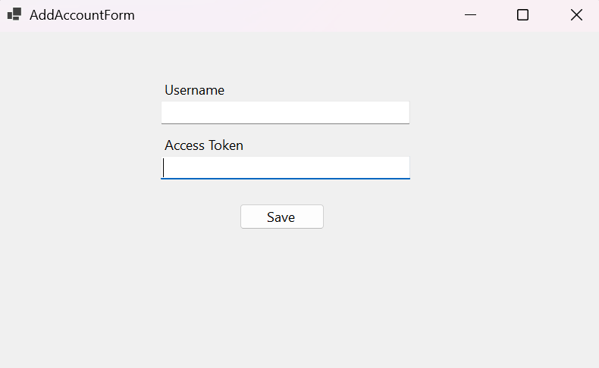

Add Flow Form
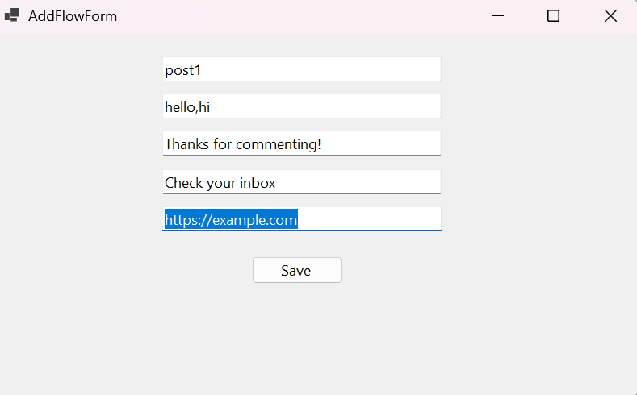

Chapter 16: Technologies Used
Technology | Purpose
C# | Application Development
Windows Forms | Desktop User Interface
SQL Server | Database Management
ADO.NET | Database Connectivity
Microsoft.Data.SqlClient | SQL Communication
Visual Studio | Development Environment
GitHub | Version Control

Chapter 17: Challenges Faced
During the development process, several challenges were faced:
- Database connection configuration.
- Role-based authentication implementation.
- Dynamic dashboard refresh system.
- Managing DataGridView operations.
- Handling SQL exceptions.
- Organizing professional UI layout.
- Exporting logs into CSV format.
These challenges improved understanding of real-world software development.

Chapter 18: Future Improvements
The future vision of InstaAutomate Dashboard is to transform it into a real-time business-grade Instagram automation platform.
The following advanced functionalities are planned for future implementation:

1. Real Instagram Graph API Integration
The current project simulates Instagram automation workflows. Future versions will integrate Meta Instagram Graph API for:
- real Instagram login
- business account connection
- media fetching
- comment monitoring
- real-time automation

2. Real-Time Follower Verification System
The system will verify whether a user follows the business account before sending promotional links.
Workflow:
Comment → Follow Check → DM Link Distribution
If the user does not follow the page:
- the system will ask the user to follow first
- after follow verification, the special link will be sent automatically

3. Instagram Post Selection Dashboard
Users will be able to:
- fetch all posts from their Instagram profile
- view post thumbnails
- select a target post
- activate automation for specific posts
This will allow business owners to run automation campaigns post-wise.

4. Real-Time Comment Monitoring
Future versions will support:
- webhook integration
- live comment detection
- automatic engagement processing
- real-time event handling

5. AI-Powered Automation Suggestions
Artificial intelligence modules may suggest:
- optimized reply messages
- campaign timing
- keyword recommendations
- engagement analytics

6. Analytics Dashboard
Future analytics system may include:
- engagement charts
- DM conversion analytics
- follow conversion tracking
- automation success rate
- campaign reports

7. Cloud-Based Architecture
Future migration plans include:
- ASP.NET Core backend
- cloud database
- API-based architecture
- multi-device synchronization

8. Mobile Application
A mobile version may be developed using:
- Flutter
- React Native
- .NET MAUI

9. Notification System
The platform may include:
- real-time notifications
- automation alerts
- DM delivery status
- failed action reports

10. SaaS Business Expansion
Long-term vision includes transforming the project into a Software-as-a-Service (SaaS) platform where multiple businesses can:
- connect Instagram accounts
- manage campaigns
- monitor automation analytics
- purchase subscription packages
The future architecture aims to support real-world commercial business automation.

Chapter 18: Future Improvements
Future improvements of the project include:
- Real Instagram API integration.
- Cloud database integration.
- Dark mode dashboard.
- Notification system.
- AI-based automation suggestions.
- Mobile application version.
- ASP.NET web-based version.
- Advanced analytics charts.
- Multi-user collaboration.
- Real-time webhook support.

Chapter 19: Conclusion
InstaAutomate Dashboard successfully demonstrates the implementation of a desktop-based automation management system using object-oriented programming concepts.
The project integrates:
- database management
- authentication systems
- dashboard analytics
- role-based authorization
- simulation engines
- activity logging
The project enhanced practical knowledge in:
- C# programming
- Windows Forms development
- SQL Server integration
- software architecture
- debugging and testing
- user interface design
This project can be further expanded into a real-world SaaS or social media management platform.

Chapter 20: References
- Microsoft Documentation – C# Windows Forms
- Microsoft SQL Server Documentation
- ADO.NET Official Documentation
- GitHub Documentation
- Visual Studio Documentation
- Stack Overflow Community
- C# Corner Tutorials

